**MODERN DATABASE SYSTEM LAB 3**

**INDIAN WEATHER ANALYTICS USING HISTORICAL DATA PART-1**

**NAME: PAVITHIRAN.V ROLL.NO: 235229122**

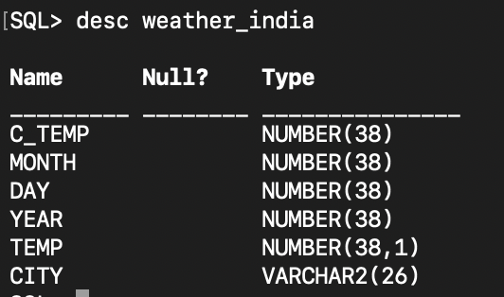

**QUESTION 1:**

SELECT MIN(TEMP) AS LOWEST_TEMP,

MAX(TEMP) AS HIGHEST_TEMP,

AVG(TEMP) AS AVG_TEMP FROM WEATHER_INDIA;

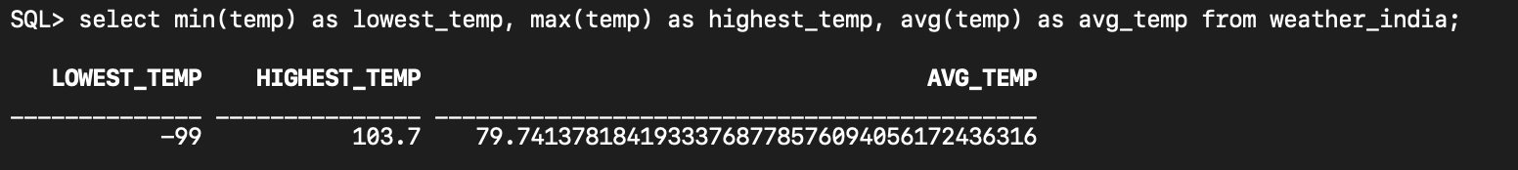

**QUESTION 2:**

SELECT AVG(TEMP) AS AVG_OF_MAY_2019_IN_CHENNAI

FROM WEATHER_INDIA

WHERE YEAR = 2019 AND

MONTH = 5 AND CITY = 'CHENNAI';



**QUESTION 3:**

SELECT DAY AS HOTTEST_DAY_IN_2019_DELHI

FROM WEATHER_INDIA

WHERE TEMP = (SELECT MAX(TEMP) FROM WEATHER_INDIA WHERE YEAR = 2019 AND CITY = 'DELHI') AND YEAR = 2019 AND CITY = 'DELHI';

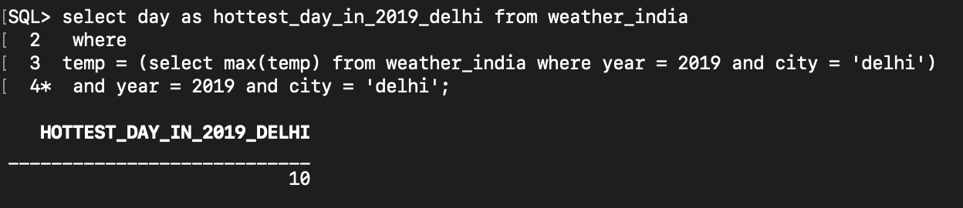

**QUESTION 4:**

SELECT DAY AS COLDEST_DAY_IN_2018_CHENNAI

FROM WEATHER_INDIA

WHERE TEMP = (SELECT MIN(TEMP) FROM WEATHER_INDIA

WHERE YEAR = 2018 AND CITY = 'CHENNAI')

AND YEAR = 2018 AND CITY = 'CHENNAI';

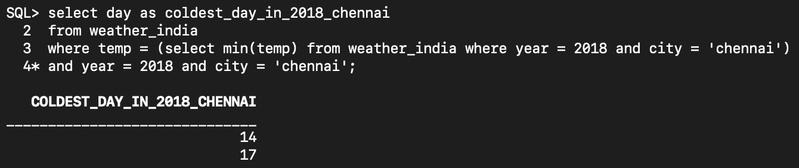

**QUESTION 5:**

SELECT YEAR AS COLDEST_YEAR

FROM WEATHER_INDIA

WHERE MONTH = 12 ORDER BY TEMP ASC

FETCH FIRST 1 ROWS ONLY;

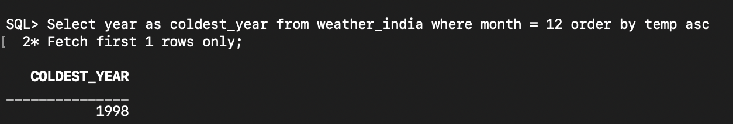

**QUESTION 6:**

SELECT CITY AS HOTTEST_CITY_IN_INDIA_2017

FROM WEATHER_INDIA

WHERE YEAR = 2017

ORDER BY TEMP ASC

FETCH FIRST 1 ROWS ONLY;

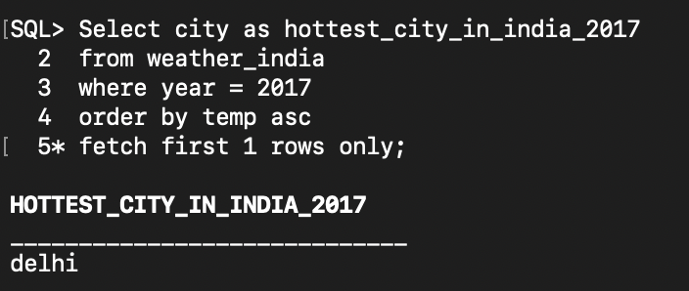

**QUESTION 7:**

SELECT CITY, AVG(TEMP) AS AVERAGE_TEMPERATURE

FROM WEATHER_INDIA

WHERE CITY IN ('MUMBAI', 'DELHI') AND MONTH = 1

AND YEAR = 2017

GROUP BYCITY;

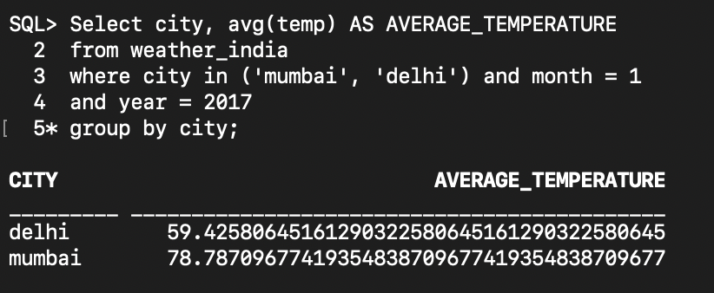

**QUESTION 8:**

SELECT DAY, MONTH, YEAR, CITY

FROM WEATHER_INDIA

WHERE TEMP = (SELECT MIN(TEMP) FROM WEATHER_INDIA)

FETCH FIRST 1 ROWS ONLY;

